January 21, 2020.

Dear OLMC Families,

Our January School Council meeting was held on Monday night. The next meeting is February 18th at 6:00 PM. All parents are welcome to attend.

One item that was discussed at length was the potential change of school start time for September 2020. Please keep in mind, that currently, this is a proposal and we are gathering information in the event we must make it operational. This will be a decision made between 2 school boards and Tri-Board Transporation (coordinates all the bussing for Kingston and area).

I would like to thank those who have provided feedback about the possible change. I have joined in discussion with those who have reached out and also shared some of my research with council last night, including a draft of what a school day timetable (below) may look like, along with the school hours at Kingston area school and length of lunch hour (on reverse). A challenge that we will continue to consider is the possible increase need for before school care and the limited options in Amherstview.

Please do not hesitate to contact me directly should you have additional concerns or feedback.

Tammy Hulton
hultonta@alcdsb.on.ca

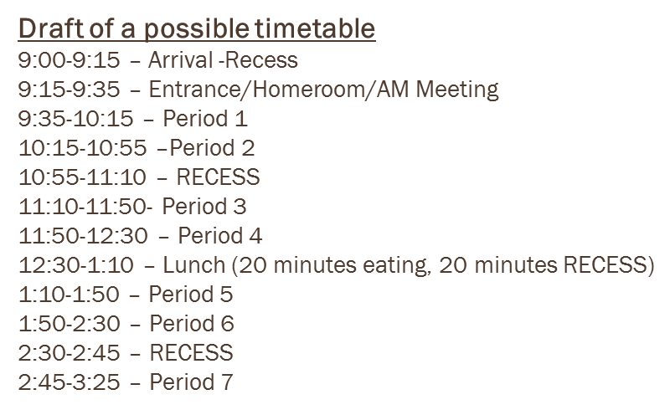

School | School Hours | Lunch | Lunch Time (half inside – half outside)
AOS | 9:10-3:20 | 12:25-1:05 | 40 min
Ecole | 8:25-2:35 | 11:20-12:00 | 40 min
Holy Name | 9:15-3:35 | 12:30-1:20 | 50 min
JJ O’Neill | 9:15-3:25 | 12:10-12:50 | 40 min
Mother Teresa | 9:05-3:35  Balanced Day | 2 – 20 minute blocks of outside. No 15 minute recess | Balance Day – 40 minutes total per day
Our Lady of Lourdes | 9:00-3:30 | 11:55-12:55 | 60 min
Sacred Heart | 8:35-2:55 | 11:40-12:30 | 50 min
John 23 | 9:05-3:35 | 12:05-1:05 | 60 min
St. Martha | 8:20-2:40 | 12:00-12:40 | 40 min
St. Patrick Harrowsmith | 9:05-3:35  Balanced Day | 2 – 20 minute blocks of outside. No 15 minute recess | Balance Day – 40 minutes total per day
St. Francis of Assisi | 8:15-2:35 | 11:15-12:15 | 60 min
SMB | 9:05-3:35 | 12:05-12:55 | 50 min
STM | 9:10-3:30 | 12:10-12:50 | 40 min
St. Paul | 8:30-3:00 | 12:10-12:50 | 40 min

